**Sample Multiple Choice Test Items by Strand and Benchmark - Grade 8 Science**

**Science as Inquiry**

**Benchmark SI-M-A5:** developing models and predictions using the relationships between data and explanations

**Use the information in the box below to answer the question.**

Pierre wants to build a model of a ramp that would be safe for students who use wheelchairs. He knows that to be safe, a wheelchair ramp should not drop more than 10 centimeters for every 120 centimeters of ramp length. Pierre has the following materials:

• a ball that will roll the way a wheelchair rolls

• a stopwatch to time the ball as it rolls

• a board that can be used as a small ramp

• blocks of wood to prop up the board at different heights

• a meterstick to measure distance

Which items are necessary for Pierre to build a correct model of the ramp?

**A.** the stopwatch and the ball only

**B.** the meterstick and the board only

**C.** the meterstick, the board, and the blocks of wood only

**D.** the board, the blocks of wood, and the ball only

**Correct response: C**

**Science as Inquiry**

**Benchmark SI-M-A6:** comparing alternative explanations and predictions

**Use the information and the table below to answer the question.**

Corey found that when he added a certain chemical to water, the water would heat up. He then performed an experiment in which he mixed different amounts of the chemical with water in a test tube and measured the temperature of the water. The results of his experiment are shown in the table below.

|  |  |  |  |  |
| --- | --- | --- | --- | --- |
| **Trial** | **Amount**  **of Water** | **Amount of Chemical** | **Temperature of Water before Adding Chemical** | **Temperature of Water 2 minutes after Adding Chemical** |
| **1** | 100 mL | 0 grams | 21ºC | 21ºC |
| **2** | 100 mL | 5 grams | 21ºC | 27ºC |
| **3** | 100 mL | 10 grams | 21ºC | 32ºC |
| **4** | 100 mL | 15 grams | 21ºC | 35ºC |
| **5** | 100 mL | 20 grams | 21ºC | 35ºC |

Which of these is a valid conclusion based on the results of Corey’s experiment?

**A.** Adding more of the chemical will always heat the water to a greater temperature.

**B.** The chemical always heats water to the same temperature.

**C.** The temperature of water is not affected by the amount of the chemical.

**D.** Adding more of the chemical will heat the water but only up to a certain temperature.

**Correct response: D**

**Science as Inquiry**

**Benchmark SI-M-B4:** using data and logical arguments to propose, modify, or elaborate on principles and models

**Use the information and table below to answer the question.**

Mabel read that regular heavy watering promotes growth in sunflower plants. She planted 6 plots of sunflowers with 5 plants each and watered each plot with a different amount of water. The table shows her results.

|  |  |  |
| --- | --- | --- |
| **Plot Number** | **Daily Amount of Water per Plant** | **Average Final Height** |
| **1** | 1 liter | 122 centimeters |
| **2** | 2 liters | 155 centimeters |
| **3** | 3 liters | 190 centimeters |
| **4** | 4 liters | 216 centimeters |
| **5** | 5 liters | 206 centimeters |
| **6** | 6 liters | 168 centimeters |

Which of these statements represents Mabel’s revised understanding of sunflower growth?

**A.** Heavy watering on a regular schedule promotes sunflower growth.

**B.** Some plants respond better to watering, while others respond better to light.

**C.** Water promotes growth up to a point, beyond which it stunts growth.

**D.** Some sunflower plants need less water than others.

**Correct response: C**

**Physical Science**

**Benchmark PS-M-A1:** investigating, measuring, and communicating the properties of different substances that are independent of the amount of the substance

Joyce put 200 milliliters of water in a beaker, put a thermometer in it, and heated it until it started to boil. She recorded a temperature of 100ºC when it started to boil. She repeated the process with 400 milliliters of water. What would be the temperature when this second sample started to boil?

**A.** twice as high as the first sample’s

**B.** slightly higher than the first sample’s

**C.** half as high as the first sample’s

**D.** the same as the first sample’s

**Correct response: D**

**Physical Science**

**Benchmark PS-M-A5:** investigating the relationships among temperature, molecular motion, phase changes, and physical properties of matter

Jo Anne took a large beaker of clean water and carefully added one drop of blue food coloring to the edge of the water’s surface. She did not touch or move the

beaker. At first, she saw blue streaks as the food coloring sank into the water, but gradually the color of the entire beaker of water became evenly blue. What

caused the blue food coloring to be mixed throughout the water?

**A.** Water molecules hitting the food coloring molecules caused the mixing.

**B.** Light shining on the surface of the water caused the mixing.

**C.** A chemical reaction between the water and the food coloring formed a new, light blue compound.

**D.** The water interacted with the food coloring, causing the blue color to fade.

**Correct response: A**

**Physical Science**

**Benchmark PS-M-B1:** describing and graphing the motions of objects

A force acting on an object that is free to move will cause a change in the speed of the object. Which graph shows how the speed of an object would change if a single constant force were applied to the object over a period of time?

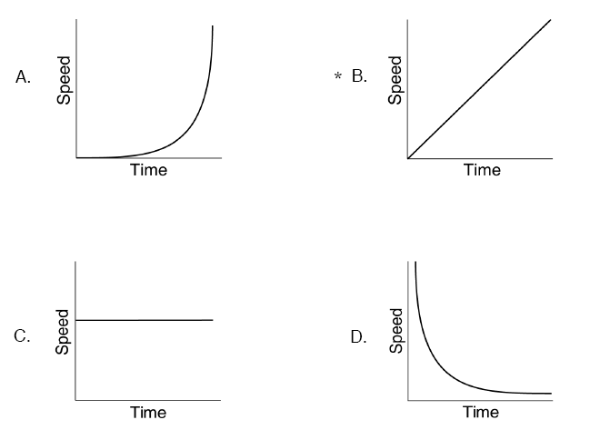

**Correct response: B**

**Physical Science**

**Benchmark PS-M-B5:** Understanding that unbalanced forces will cause changes in the speed or direction of an object’s motion

Jerry threw a ball into the air. It followed a curved path and soon fell to the ground because

**A.** air friction stopped the ball.

**B.** gravity changed the ball’s direction.

**C.** the ball was not thrown hard enough.

**D.** the ball was not thrown straight up.

**Correct response: B**

**Physical Science**

**Benchmark PS-M-C3:** understanding that the Sun is a major source of energy and that energy arrives at Earth’s surface as light with a range of wavelengths

The radiant energy that comes to Earth from the Sun is

**A.** only one wavelength that we see as yellow.

**B.** a narrow band of wavelengths that is entirely visible light.

**C.** mostly long wavelengths that become heat energy.

**D.** a range of many wavelengths from long to very short.

**Correct response: D**

**Physical Science**

**Benchmark PS-M-C3:** understanding that the Sun is a major source of energy and that energy arrives at Earth’s surface as light with a range of wavelengths

Denise was driving east over a hill in the afternoon, shortly after a rain shower. Suddenly the sun broke through the clouds, and she saw a rainbow ahead of her.

Which of the following made the rainbow possible?

**A.** Sunlight can be separated into all the colors of the rainbow.

**B.** Water reflects sunlight like a mirror to make it look colored.

**C.** Overhead black clouds reflect in puddles to cause a mirage.

**D.** Air pollution causes the sky to look colored under these conditions.

**Correct response: A**

**Life Science**

**Benchmark LS-M-A2:** comparing and contrasting the basic structures and functions of different plant and animal cells

Which statement about plant and animal cells is true?

**A.** Both have a cell wall to give them support.

**B.** Both have a large vacuole to store water.

**C.** Both use mitochondria to produce energy.

**D.** Both use chloroplasts to store energy.

**Correct response: C**

**Life Science**

**Benchmark LS-M-A2:** comparing and contrasting the basic structures and functions of different plant and animal cells

The process of cellular respiration occurs in

**A.** both plant and animal cells.

**B.** plant cells only.

**C.** animal cells only.

**D.** neither plant nor animal cells.

**Correct response: A**

**Life Science**

**Benchmark LS-M-A2:** comparing and contrasting the basic structures and functions of different plant and animal cells

**Use the diagrams below of an animal cell and a plant cell to answer** **the question.**

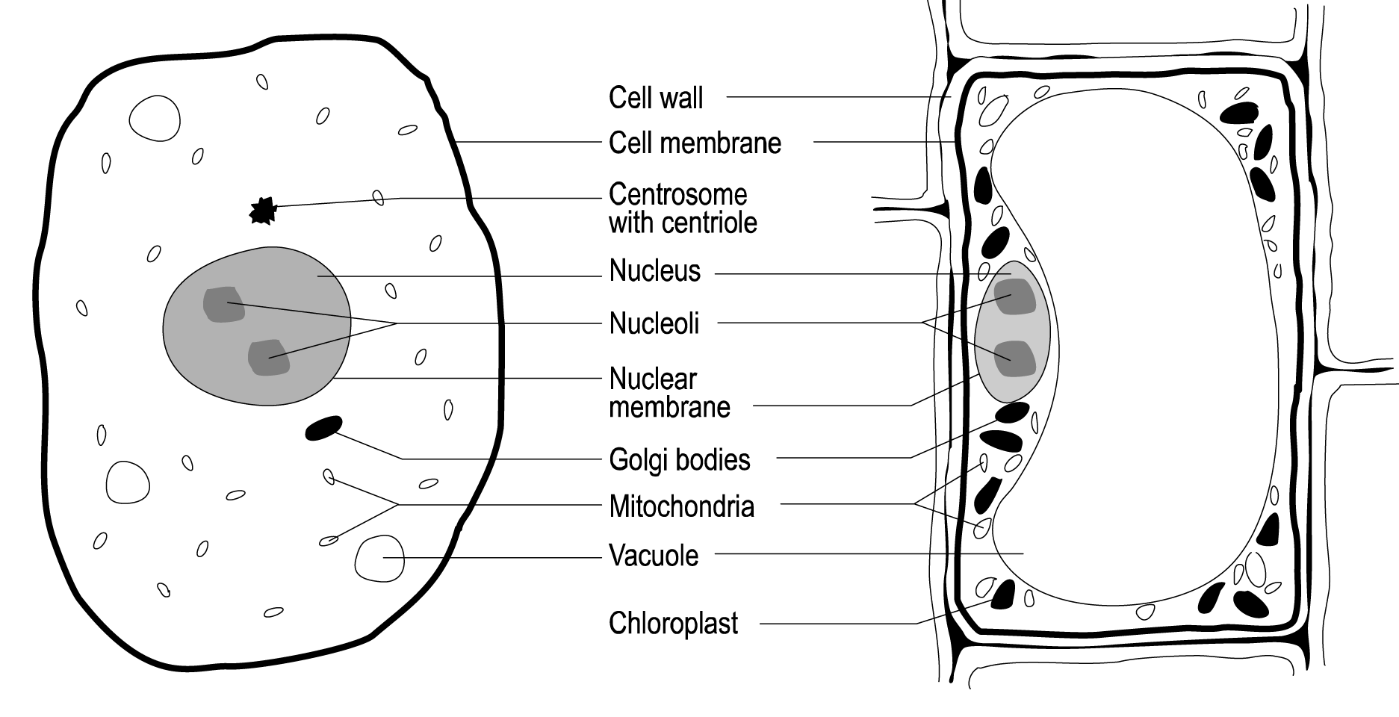

Features of plant cells that clearly make them different from animal cells are

**A.** a larger nucleus and fewer chromosomes.

**B.** a rigid cell wall and chloroplasts.

**C.** more cytoplasm and smaller vacuoles.

**D.** a changing size and indefinite shape.

**Correct response: B**

**Life Science**

**Benchmark LS-M-C2:** modeling and interpreting food chains and food webs

Use the food web below to answer the question .

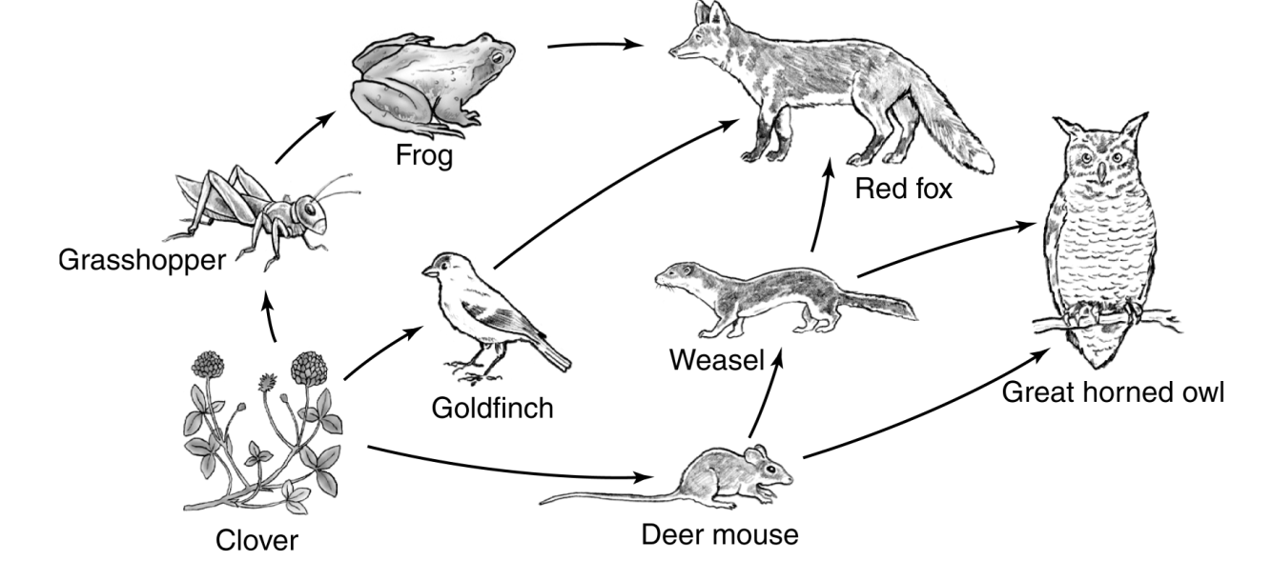

Which of these are not represented in the food web?

**A.** producer

**B.** primary consumers

**C.** secondary consumers

**D.** decomposers

**Correct response: D**

**Life Science**

**Benchmark LS-M-C3:** investigating major ecosystems and recognizing physical properties and organisms within each

Use the picture below to answer the question.

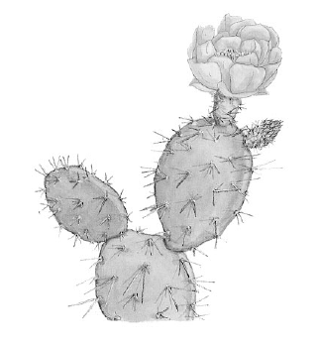

The cactus plant shown above lives in a desert environment.

Which characteristic of this plant could be found in many other desert plants?

**A.** a deep root system for gathering water

**B.** lush growth that serves to trap water if it rains

**C.** broad leaves that protect the plants from the hot sun

**D.** leaves and stems that are adapted to conserve water

**Correct response: D**

**Life Science**

**Benchmark LS-M-D2:** explaining how some members of a species survive under changed environmental conditions

Over a long period, some flowering plants have become dependent on honeybees for pollination. In recent years, a form of mite has infected and killed

the honeybees in many areas of the country. Since this has happened, the once bee-dependent plants with the best chance of surviving are those that

**A.** grow taller so that the few remaining honeybees will find them.

**B.** change their flowers so that wind will fertilize them.

**C.** have always attracted many other insects as wells as honeybees.

**D.** have seeds that stay alive for a long time in the environment.

**Correct response: C**

**Earth and Space Science**

**Benchmark ESS-M-A2:** understanding that Earth’s crust and solid upper mantle are dividing plates that move in response to convection currents (energy transfers) in the mantle

Use the diagram below to answer the question.

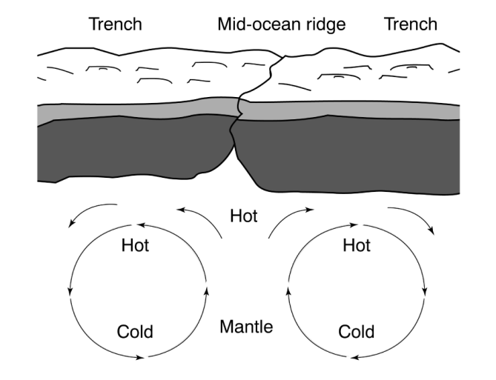

Based on the diagram, which process explains why less dense, hot magma rises to the surface to displace more dense, cooler magma?

**A.** conduction

**B.** diffusion

**C.** radiation

**D.** convection

**Correct response: D**

**Earth and Space Science**

**Benchmark ESS-M-A6:** explaining the processes involved in the rock cycle

Which statement is the best description of what happens in the rock cycle?

**A.** Rocks on old mountains are gradually weathered away, while mountain building and volcanism form new mountains.

**B.** Once formed, rocks stay in place until rocks above them are weathered away and they reach the surface.

**C.** As sedimentary rocks are buried deep below other rocks, they are changed by heat and pressure, eventually return to the surface, and are weathered again.

**D.** Younger sedimentary rocks are always deposited on top of older metamorphic or igneous rocks.

**Correct response: C**

**Earth and Space Science**

**Benchmark ESS-M-A7:** modeling how landforms result from the interaction of constructive and destructive forces

El Cajon Pass in California is becoming higher than the land around it at a rate of nearly 1 centimeter each year. Which statement is true about the area?

**A.** Erosion is slower than uplift at El Cajon Pass.

**B.** Plates are separating at El Cajon Pass.

**C.** Mountain building is slower than erosion at El Cajon Pass.

D. Erosion and uplift are balanced at El Cajon Pass.

**Correct response: A**

**Earth and Space Science**

**Benchmark ESS-M-C3:** investigating the force of gravity and the ways gravity governs motion in the solar system and objects on Earth

When people walked on the Moon, they found that they could jump higher than they could back on Earth. Why is this true?

**A.** There is no atmosphere on the Moon.

**B.** The Moon exerts less gravitational force than Earth.

**C.** Space suits helped them jump higher.

**D.** The Moon rotates faster than Earth does.

**Correct response: B**

**Science and the Environment**

**Benchmark SE-M-A3:** defining the concept of pollutant and describing the effects of various pollutants on ecosystems

Which activity is **most likely** to add pollutants to the environment?

**A.** watering a garden

**B.** pulling weeds from a lawn

**C.** installing a wooden fence

**D.** burning leaves

**Correct response: D**

**Science and the Environment**

**Benchmark SE-M-A3:** defining the concept of pollutant and describing the effects of various pollutants on ecosystems

Which of these **best** defines the term *pollutant*?

**A.** anything humans add to the atmosphere and oceans

**B.** any substance that is harmful to the environment

**C.** any substance that is a waste product of industry

**D.** a substance that does not break down over time

**Correct response: B**

**Science and the Environment**

**Benchmark SE-M-A4:** understanding that human actions can create risks and consequences in the environment

Many scientists accept the theory that excess emission of carbon dioxide from cars and industry causes a layer of gas in the upper atmosphere that traps heat.

This in turn causes the average temperature on Earth to rise. Which of the following observations supports that theory?

**A.** The summer of 1998 was one of the hottest summer seasons on record.

**B.** Carbon dioxide gas from cars and industry is a product of burning that produces heat.

**C.** Carbon dioxide in the upper atmosphere absorbs and re-emits heat radiated from Earth’s surface.

**D.** Radiation on Earth’s surface is increasing because of a hole in the ozone layers.

**Correct response: C**

**Science and the Environment**

**Benchmark SE-M-A5:** tracing the flow of energy through an ecosystem and demonstrating a knowledge of the roles of producers, consumers, and decomposers in the ecosystem

In an ecosystem, which list of organisms is in the correct order from producer to top-level consumer?

**A.** field mouse, grass, hawk, snake

**B.** snake, field mouse, hawk, grass

**C.** grass, field mouse, snake, hawk

**D.** snake, grass, field mouse, hawk

**Correct response: C**

**Science and the Environment**

**Benchmark SE-M-A7:** demonstrating knowledge of the natural cycles, such as the carbon cycle, nitrogen cycle, water cycle, and oxygen cycle

In the oxygen cycle, which group of organisms replenishes a large portion of the atmospheric oxygen supply?

**A.** mammals

**B.** fungi

**C.** insects

**D.** plants

**Correct response: D**

**Sample Constructed Response Test Items by Strand and Benchmark**

**Physical Science**

**Benchmark PS-M-A5:** investigating the relationships among temperature, molecular motion, phase changes, and physical properties of matter

**Use the diagram below to answer the question.**

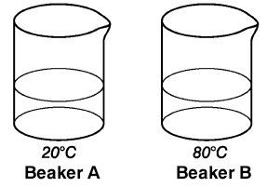

Two beakers were prepared with 150 milliliters of water at two different temperatures, as shown above. Two drops of food coloring were then added carefully at the surface of each beaker of water. In which beaker would the food coloring spread faster through the entire beaker? Explain your answer.

**Scoring Rubric:**

|  |  |
| --- | --- |
| **Score** | **Description** |
| **2** | The student chooses beaker B **AND** gives a correct and clear explanation of why that is the correct choice. A clear explanation would mention diffusion or the hotter temperature in beaker B. There are no errors. |
| **1** | The student chooses beaker B but is wrong or unclear about the explanation or offers no explanation **OR** chooses beaker A but shows some understanding in defending the choice or has some concept of diffusion. |
| **0** | The student’s response is totally incorrect, irrelevant, too brief to evaluate, or blank. |

**Scoring Notes:**

The food coloring would spread, or diffuse, faster in the beaker with the hottest water. This is because the molecules of water that would collide with and

cause movement of the food coloring molecules would have more energy and be moving faster through the volume of water.

**Life Science**

**Benchmark LS-M-A1:** describing the observable components and functions of a cell, such as the cell membrane, nucleus, and movement of molecules into and out of cells

The diagram below shows water molecules moving through the cell membrane into a body cell.



**A.** What is the name of the process?

**B.** Explain what causes the molecules to move into the cell.

**Scoring Rubric:**

|  |  |
| --- | --- |
| **Score** | **Description** |
| **2** | The student names the process **AND** explains what causes the molecules to move into the cell. Response contains no errors. |
| **1** | The student names the process or explains what causes the molecules to move into the cell **OR** the student completes parts A and B with minor errors. |
| **0** | The student’s response is totally incorrect, irrelevant, too brief to evaluate, or blank. |

**Scoring Notes:**

*Part A:* osmosis, diffusion, passive transport

*Part B:* Initially, there is a higher concentration of water molecules outside the cell, which creates a concentration gradient (difference in concentration). To achieve equilibrium, water molecules flow into the cell. This can also be expressed as the molecules spreading themselves equally/going where there are fewer of the same molecules. Also acceptable is that the molecules try to even out between the inside and outside of the cell.

**Life Science**

**Benchmark LS-M-B3:** describing how heredity allows parents to pass certain traits to offspring

The ability to roll the tongue is a dominant trait, designated by R. The inability to roll the tongue is a recessive trait designated by r. Kathy’s mother has a

genotype of RR, and her father cannot roll his tongue.

**A.** What is her father’s genotype?

**B.** What is the probability that Kathy will be able to roll her tongue?

You may use the Punnett square to help you find your answer.



**Scoring Rubric:**

|  |  |
| --- | --- |
| Score | Description |
| **2** | The student correctly identifies the father’s genotype and the probability that Kathy will be able to roll her tongue. Response contains no errors. |
| **1** | The student correctly identifies the father’s genotype or the probability that Kathy will be able to roll her tongue. |
| **0** | The student’s response is totally incorrect, irrelevant, too brief to evaluate, or blank. |

Scoring Notes:

*Part A:* The father’s genotype would be rr. (Note that it is not OK to substitute other letters.) This genotype may be pulled from the Punnett square if necessary.

*Part B:* There is a 100 percent likelihood that Kathy will be able to roll her tongue

(probability = 1, 4/4).

**Additional Information:** The Punnett square is only a tool for students and IS NOT TO BE SCORED.

r r

|  |  |  |
| --- | --- | --- |
| R  R | Rr | Rr |
| Rr | Rr |

**Earth and Space Science**

**Benchmark ESS-M-A1:** understanding that Earth is layered by density with an inner and outer core, a mantle, and a thin outer crust

The outer layers of Earth are the crust and the mantle.

**A.** Describe the difference between the density of the crust and of the mantle.

**B.** Describe the difference between the thickness of the crust and of the mantle.

**Scoring Rubric:**

|  |  |
| --- | --- |
| **Score** | **Description** |
| **2** | The student correctly describes the differences in density and thickness between the crust and mantle. Response contains no errors. |
| **1** | The student describes the difference in either density **or** thickness between the crust and mantle. Response may contain errors.  **OR**  The student correctly describes both differences but includes explanations that contain errors. |
| **0** | The student’s response is totally incorrect, irrelevant, too brief to evaluate, or blank. |

**Scoring Notes:**

*Part A:* The crust is less dense than the mantle (density increases from outermost to innermost layer of Earth).

*Part B:* The crust is a very thin layer, while the mantle is very thick (the thickest layer, in fact).

**Earth and Space Science**

**Benchmark ESS-M-C2:** comparing and contrasting the celestial bodies in our solar system

There are many differences between the planets, even though they are all part of the same solar system. For example, Earth and Jupiter are very different.

Describe **two** ways Earth is different from Jupiter.

**Scoring Rubric:**

|  |  |
| --- | --- |
| **Score** | **Description** |
| **2** | The student correctly identifies two major differences in the two planets. Both planets need to be identified. If both planets are names in one of the parts and only one is mentioned in the other part, it can be counted as correct. Response contains no errors. |
| **1** | The student identifies one difference or attempts two difference but make errors or omissions.  **or**  The student identifies two differences are mentioned but the planets are not identified. |
| **0** | The student’s response is totally incorrect, irrelevant, too brief to evaluate, or blank. |

**Scoring Notes:**

The major differences are: Earth is rocky; Jupiter is gaseous (Earth is more dense than Jupiter). Earth has one moon; Jupiter has sixteen. An Earth day is 24 hours; a Jupiter day is 9.9 hours. Earth revolves around the sun in one year; Jupiter revolves around the sun in twelve years. Jupiter has rings; Earth does not. Earth has life; Jupiter does not. Jupiter’s mass is 314 times the mass of Earth. There are other specific differences that might be given (Jupiter has a giant red spot, etc.). Students should be given credit for comparisons without specific quantitative values.

**Science and the Environment**

**Benchmark SE-M-A4:** understanding that human actions can create risks and consequences in the environment

Suzanne helped her dad change the motor oil in his car. Suzanne poured the old motor oil onto the grass by the fence. Describe **two** ways this could eventually

affect the water supply.

**Scoring Rubric:**

|  |  |
| --- | --- |
| **Score** | **Description** |
| **2** | The student describes two key ways Suzanne’s action could affect the water supply. Response contains no errors. |
| **1** | The student describes one key way Suzanne’s action could affect the water supply. |
| **0** | The student’s response is totally incorrect, irrelevant, too brief to evaluate, or blank. |

**Scoring Notes:**

The motor oil could enter the soil, then enter the groundwater (by rain, moisture leaking through the landfill liner, etc.). The water could run off from the surface, carrying the oil into rivers, lakes, or streams. Either way, groundwater and runoff water flows into the rivers, lakes, bayous, and coastal waters.

No credit is to be given for the oil clogging pipes.

**Task**

**The following article is adapted from a webpage that Dr. Ben Booth, Senior Climate Scientist, posted on the website of the United Kingdom’s National Weather Service, a government office of weather and climate research. Read and study the article. Then answer questions 1 through 5.**

**Climate Feedback Loops**

Climate feedback loops are an important area of research for scientists.

## What is a climate feedback loop?

A climate feedback loop happens when a change in our climate causes an environmental impact that produces further climate change. Climate feedback loops can be both negative and positive:

* Negative feedback loop: A negative feedback loop occurs when an environmental impact offsets the climate change such that they balance out. Under global warming, the impact would create a cooling effect, offsetting the warming trend.
* Positive feedback loop: A positive feedback loop occurs when an environmental impact increases the climate change such that the first change is amplified. Under global warming, the impact would add to climate warming by creating further heating.

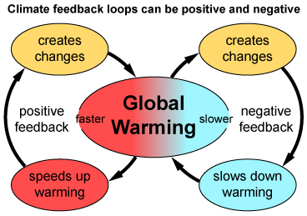

## Why are feedback loops so important to climate change?

Feedback loops have the ability to greatly affect climate change. The big question is what overall effect the world’s positive and negative feedback loops will have on climate change.

The more we understand about them, the more confidence we have in our climate projections for the future. The better our projections, the better we can understand climate change and prepare for it.

## Which climate feedback loops are well understood?

## Some types of feedback loops are fairly well understood, such as those involving water vapor and albedo. Scientists use these feedback loops to improve their predictions about climate change through the use of computer models. This means that scientists have taken into consideration the effect these feedback loops will have as the climate warms in the future.

### Water Vapor (Positive Feedback)

As air gets warmer, its ability to hold moisture increases. Our atmosphere is getting warmer because of climate change and, as a result, it is holding more water vapor. Water vapor is a powerful greenhouse gas—when in the atmosphere, it helps the Earth hold on to more energy from the Sun. So a warming climate means more water vapor, which in turn warms the climate further.

### Albedo (Positive Feedback)

Albedo is the percentage of light reflected by a surface, which is a very important consideration in climate science. A surface with a high albedo, such as snow or sand, will reflect more sunlight back out to space. The lower the albedo, the more energy and heat is absorbed.

Global warming is causing ice and snow to melt, revealing the land or ocean underneath. Ice and snow reflect a lot of sunlight—certainly more than land and the oceans. So as the ice melts, more of the Sun’s energy is absorbed and so the planet gets warmer still—which in turn melts even more snow and ice.

## Which climate feedback loops are less well understood?

Other feedbacks, such as the global carbon cycle, are not as easy to understand. They are being included in models, but more research is needed to fully understand these processes. The models are updated as new information becomes available.

### Global Carbon Cycle (Currently Negative Feedback)

For every ton of carbon dioxide (CO2) released into the atmosphere, within a year, about half of that will be absorbed by the ocean and land—for example, through trees and plants.

This process helps reduce the effect of CO2 emissions on global warming. However, if large quantities of carbon dioxide continue to be emitted, it could decrease the benefit of this cycle, which would have a huge impact on the future of the climate.

Global warming could affect the carbon cycle in two areas, the ocean and the land:

1. Ocean changes can result in positive climate change feedback loops, for two reasons:

As the ocean absorbs CO2, it becomes more acidic. Acidic water cannot absorb as much additional CO2.

* + As the temperature of the ocean increases, its capacity to absorb CO2 is also reduced.

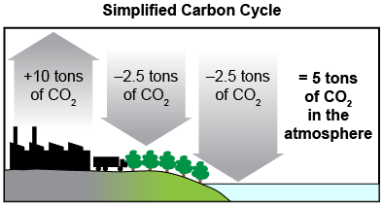

The illustration above is a simplified carbon cycle, showing current CO2 absorption rates of the land and oceans.

1. Land changes can result in positive or negative climate change feedback loops. Examples include:
   * Negative feedback: As temperatures increase, the areas in which trees can grow will extend north to higher latitudes. New trees will absorb CO2, taking it out of the atmosphere.
   * Positive feedback: As temperatures increase, soils, plants, and trees in tropical zones will become more heat stressed. This could cause the release of the huge amounts of carbon they store, threatening the future of important ecologies such as the Amazon Rain Forest.

A lot of research continues to go on in this area. Advances in understanding will enable us to improve our confidence in projections resulting from climate models.

**Study the information in the *Climate Change* article before answering the question.**

**1.** Which model **best** shows how increased melting of snow and ice affects climate change?

**A. 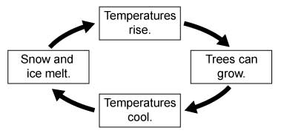 C.** 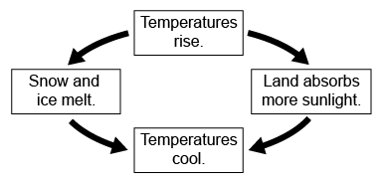

**B.** 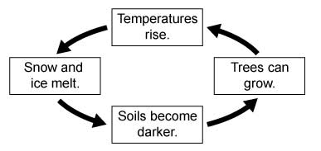  **D.** 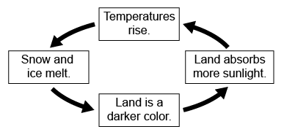

**2.** What is the **main** way scientists measure the extent of snow and ice cover in the Arctic and Antarctic?

**A.** data collected from boats

**B.** photographs taken from helicopters

**C.** images taken by satellites

**D.** estimates developed by computer models

**3.** The flowchart shows some of the causes and effects of global warming.

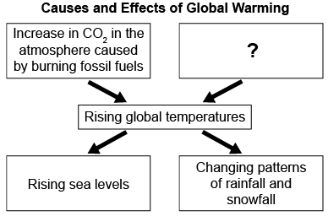

Which cause **best** completes the flowchart?

**A.** Emissions of chlorofluorocarbons (CFCs) into the atmosphere

**B.** Destruction of forests, especially tropical rain forests

**C.** Increases in particulate pollution, such as soot

**D.** Destruction of ecosystems and loss of biodiversity caused by invasive species

**4.** One effect of global warming is the retreat of mountain glaciers across the world. This results in less groundwater and water in streams in the summer.

What type of feedback loop would **most likely** be a result of glacial retreat, and why?

**A.** A negative feedback loop because reduced evaporation lowers the amount of water vapor in the air near the ground.

**B.** A negative feedback loop because the rate of decomposition, which releases CO2, is slower when the ground is drier.

**C.** A positive feedback loop because reduced evaporation reduces the amount of high cloud cover.

**D.** A positive feedback loop because a drier landscape is more susceptible to wildfires.

The following question requires you to write an extended response that combines information from the source with your knowledge of science.

To earn full credit, you should:

* Read the question and then study the information in the *Climate Change* article.
* Answer **all** parts of the question **and** support your ideas with examples, data, facts, or details.
* Write a response that is long enough to fully address the topic. This will require more than one paragraph. Responses with fewer than 25 words will not be scored.

**5.** One of the effects of global warming is rising sea levels. Analyze the causes and effects of rising sea levels. Your response should:

* Describe achange resulting from global warming that can cause sea levels to rise.
* Explain why rising sea levels can cause problems for coastal ecosystems and communities, even if they remain above sea level. Provide at least **two** examples in your explanation.
* Explain at least **two** actions humans can take to help prevent damage caused by rising sea levels.

**Rubric**

Exemplary Response

1. D

2. C

3. B

4. D

5. When global average temperatures rise, snow and ice melt, especially in Greenland and the Antarctic. Glacial melting sends new water into the oceans and causes sea levels to rise even further. Unfortunately, melting snow and ice also exposes more dark land, which absorbs heat and causes even more snow and ice to melt, making the warming and melting trend worse, and causing sea levels to rise even more.

Rising sea levels are very challenging for coastal ecosystems and communities. Some coastal ecosystems or human communities may actually be completely drowned under the new, higher ocean. This is already happening to the Maldive Islands, for example. It is also happening to parts of the coast of Louisiana. Even when land is not actually underwater, there can be many problems caused by rising sea levels. Tides and storm surges can increase the frequency and severity of flooding. Sea level rise made Hurricane Sandy more damaging to New York and New Jersey than it otherwise might have been. Salt water intrusion can cause land and groundwater to become salty, which harms or kills many plants. When plants are hurt by salt water, the animals that depend on them may also decline or die out. Also, sources of drinking water can be contaminated. For example, in St. Tammany Parish, wells were contaminated by salt water after Hurricane Katrina.

There are many ways humans can reduce damage from rising sea levels. In Louisiana, restoring coastal marshlands helps to reduce salt water intrusion and storm surges. Other areas may benefit from building seawalls to prevent flooding. Finally, humans should work to reduce their carbon dioxide emissions so that global warming is reduced, which would help prevent additional sea level rise.

|  |  |
| --- | --- |
| **Score** | **Rubric (Question #5)** |
| **4** | * The student’s response demonstrates an in-depth understanding of the causes and effects of sea level rise. * The student completes all key components of the task accurately and communicates ideas effectively. The response:   + Explains at least one reason global warming leads to sea level rise.   + Explains at least two examples of how sea level rise negatively impacts coastal communities, even when they are not permanently inundated.   + Explains at least one reasonable action humans can take to mitigate the effects of sea level rise or reduce the likelihood of further warming. * The student’s response is extensively supported by relevant evidence in the form of details, data, and/or examples. * Where appropriate, the student uses a higher level of reasoning skills that may include applications, procedures, etc. * The response contains no scientific errors. |
| **3** | * The student’s response demonstrates a good understanding of the causes and effects of sea level rise, although less important ideas or details may be overlooked or misunderstood. * The student completes most important aspects of the task accurately and communicates clearly. * The student’s response is sufficiently supported by relevant evidence. * The student’s logic and reasoning may contain minor flaws. * The response contains minor scientific errors. |
| **2** | * The student’s response demonstrates a limited understanding of the causes and effects of sea level rise, and may show gaps in conceptual understanding. * The student completes some parts of the task successfully. * The student’s response is not sufficiently supported by relevant evidence. * The response contains scientific errors. |
| **1** | * The student’s response demonstrates a basic understanding of the causes and effects of sea level rise. * The student completes only a small portion of the task. * The student’s response contains little or no support of relevant evidence. * The response contains major scientific errors. |
| 0 | The response attempts to address the prompt, but is mostly or entirely incorrect or contains some correct work that is irrelevant to the skill or concept being measured. |