Measurement Study Guide
Lesson Objective
l can select and use appropriate tools and metric system units to make observations.
Base S.I. Units
MASS: gram (g)
LENGTH: meter (m)
LIQUID VOLUME: Liter (L), ml
SOLID VOLUME: cubic meters (m³)
S.I. Prefixes
Added to beginning of base units
Kilo (k) means x1,000 BIG measurements
Centi (c) means ÷100 SMALL measurements
Milli (m) means ÷1,000 TINY measurements

Length
Distance between 2 points
Tools: ruler, meter stick, tape measure
Common units: m, cm, mm, km
Metric Units
1 Kilometer (km) = 1000 meters
1 Meter = 100 Centimeters (cm)
1 Meter = 1000 Millimeters (mm)
1 centimeter = 10 millimeters
Mass
Mass is a measurement of the amount of matter in an object.
For an object, mass is always the same no matter where the object is located.
Mass is measured using a balance.
Units
The units used to measure mass are kilogram (kg), milligram (mg), and gram (g).
Weight
A measurement of the pull of gravity on an object.
Varies depending on where the object is located.
Is measured using a spring scale.
How to read a triple beam balance: Once you have balanced the scale, you add up the amounts on each beam to find the total mass.

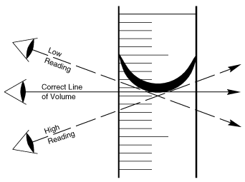
Volume
A measurement of the amount of space something takes up.
A. Measuring the volume of liquids with a Graduated Cylinder
Your eye should be level with the top of the liquid
You should read to the bottom of the MENISCUS or curve

Measuring Volume of Rectangular solids
- measure with a ruler the length (L), width (W) and height (H) of the object.
- multiply the 3 numbers together.
- The product is the volume of the object.
- unit of measure would be mm³, cm³, m³, etc.

Measuring Volume of Irregular Objects aka The Displacement Method
1.Fill the graduated cylinder at least halfway with water.
2.Record the volume of the water.
3.Drop the object into the water without splashing.
4.Record the volume of the water and the object together.
5.Subtract the volume of the water from the volume of the water and object. This is the volume of the object.
6.Remember- Convert liquid volume units (ml) to solid volume units (cm³)

Density is
a measure of how tightly packed the molecules are in an object; the amount of matter within a certain volume.
To find the density
- Find the mass of the object
- Find the volume of the object
- Divide
- Density = Mass g
- Volume cm³
- ALWAYS REMEMBER UNITS!

Metric Unit Conversion Chart
Kilo-
1000 | Hecto-
 | 100 | Deka-
To Convert:  Move the decimal  the same number of spaces  -and in the same direction  as you move on the chart. |  | 10 | -liter  -gram  -meter  -second
 |  |  | 1 | deci-
 |  |  |  | 0.1 | centi-
 |  |  |  |  | 0.01 | milli-
 |  |  |  |  |  | 0.001

